The Koch Snowflake – Mathematics HL Portfolio

By Alexander N. Sørnes, 2IB

The purpose of this document is to explore Koch's snowflake, a fractal that models a snowflake. It was discovered by Helge von Koch in 1904. The model starts as an equilateral triangle, and for each step the middle third of each side is removed, creating new triangles their places.

- The First Stages

n | N | l | P | A
0 | 3 | 1 | 3
1 | 12 |  | 4
2 | 48
3 | 192

Number of sides (N): Each side is thus divided into three parts, and a new side is added; for each side there are now four, and thus the number of sides is quadrupled for every stage of the triangle.
Length of a side (l): As each side is divided into three, the length of a side decreases threefold for each stage.
Length of perimeter (P): This is simply the product of the number of sides and the length of each side.
Area (A): The area for each stage is the area of the new triangles plus the area of the previously added triangles. The area of the new triangles can therefore be written as a sum of a geometric series, but the 0th term, the area of the starting triangle, must be added to each stage.

- Graphs

These graphs show the development of N, l, P and A against n.

- Generalization
n | N | l | P | A
0
1
2
3
Using the development described in 1, the table can be expanded to show the patterns.
I established the following formula for the number of sides. It initially has three sides, and number of sides is increased fourfold for each stage.
for all nZ⁺
Much the same can be said for the length of each side.
for all nZ⁺
Since the length of perimeter equals the length of each side times number of sides, I got the following.
, so for all nZ⁺
The area is in fact the sum of a geometric series, where and , added to the area of the original triangle (at stage 0). The area of the original triangle can be found as follows; first finding the height of the triangle, and then the area by multiplying height and half a side length.

Looking at the data for Area in part 1 and removing the area of the original triangle, as it is not a part of the series formula, the following value for r is found (here illustrated by the difference between stage 1 and 2).

These values can then be written in the series formula, with the notable exception that the starting area is added to the sum, instead of being a part of the standard formula for the sum of a geometric series.
for all nZ⁺

- The 4th Stage

n | N | l | P | A
4

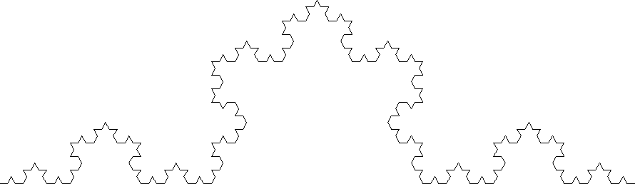
This drawing of a side of the Snowflake at the fourth stage verifies the predictions from the formulas.
Counting half the sides gives 128, and since it is obviously symmetrical at the middle, this totals 256 sides on one of the three original sides of the triangle. This gives the same result as the formula,
Measuring the length of a side can be done quite accurately in a drawing program. The length of a side at stage zero is 890 pixels, while the length of a side at stage four is 11 pixels.

A pixel cannot be divided, so there is therefore a slight inaccuracy. Since the formulae for length of a side and number of sides are correct, the formula for the perimeter must also be true.

- Large Values of n

- Towards Infinity
There is no limit for how large the perimeter can be; it goes towards infinity as n goes towards infinity. In fact, the greater the value of n, the greater the difference between each stage of P. This can be clearly seen from the formula for P.
The values of A change differently, however. As all geometric series with a common ratio |r| < 1, it has a sum to infinity.

- Induction
I have already proven that the formula for the addition to the area is true for n = 1, 2 and 3, so it must also be true for n = k. If the formula for additional area for each stage is true, so that it can be written as the formula for geometric series, the formula for the area must also be true, as it is simply the formula for the sum of a geometric series (added to the area of the triangle at stage 0). Proving that the formula for sum of a geometric series is not within the scope of this investigation.

If A_{k} is true, then

Thus,

- It is thus true for n = 1, n = k and n = (k + 1), so it is proved by the principle of mathematical induction.

